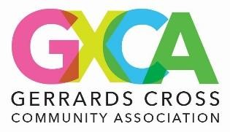
SNOOKER MEMBERSHIP APPLICATION FORM
Membership fee: £25 annually (the membership year runs from 1st April to 31st March)
Title (Mr/Mrs/Miss/Other):
First Name: | Surname:
Address:
Post code: | Telephone:
Email:
GXCA Member Number
Data Protection & Privacy (GDPR)
By signing this form, you consent to GXCA storing and processing your personal data in accordance with the UK Data Protection Act 2018 and GDPR.
Your details will only be used for the purposes of administering your Snooker Club membership and contacting you regarding relevant club activities.
- ☐ I consent to my personal data being stored and used for GXCA Snooker Club purposes only.
- ☐ Membership Directory Consent Clause (recommended but optional). By ticking this box and signing below, I consent to the inclusion of my name, contact information, and other relevant membership details in the GXCA Snooker Club Membership Directory. I understand that this directory is intended for use by GXCA Snooker Club members only and will not be shared publicly without my further consent. I acknowledge that I may request to update or remove my information at any time by contacting office@gxca.org.uk.
- ☐ I would like to receive updates about GXCA events, activities, and promotions (optional).

Declaration
☐ I confirm that the information I have provided is accurate and complete.
☐ I agree to abide by the rules and code of conduct of GXCA and the Snooker Club.
☐ I understand that Snooker Club membership is conditional upon being a current
member of GXCA.

SIGNATURE:
DATE:

The information provided on this form will be held on computer records but will not be divulged to third parties.
Registered under the Data Protection Act

Gerrards Cross Community Association, 8 East Common, Gerrards Cross, Bucks SL9 7AD Telephone: 01753 883759 Website: www.gxca.org.uk Email:
office@gxca.org.uk
GXCA CIO Charity Number 1208327

